FPT ACADEMY INTERNATION
--o0o--


Employee Transfer Management System
Installation Guide Mode 1

HA NOI 11 - 2010

B1. The first: you need star SQL Server Configuration Manager
Start → All Programs→ Microsoft SQL Server 2005→ Configuration Tools→ SQL Server Configuration Manager
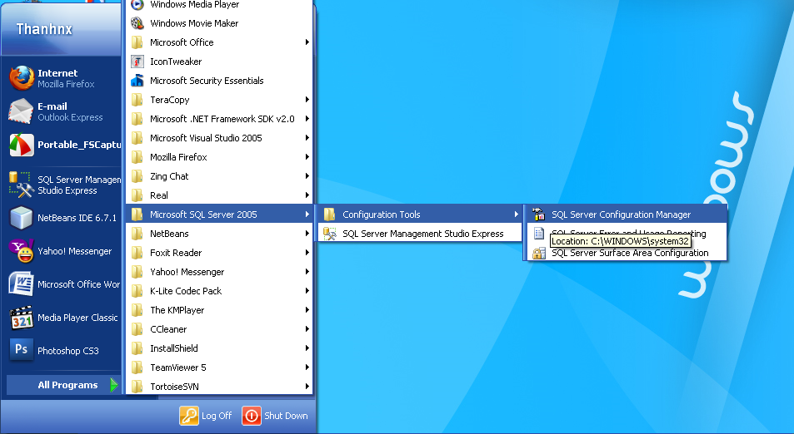

Select Protocols for SQLEXPRESS > Right click TCP/IP > Enabled
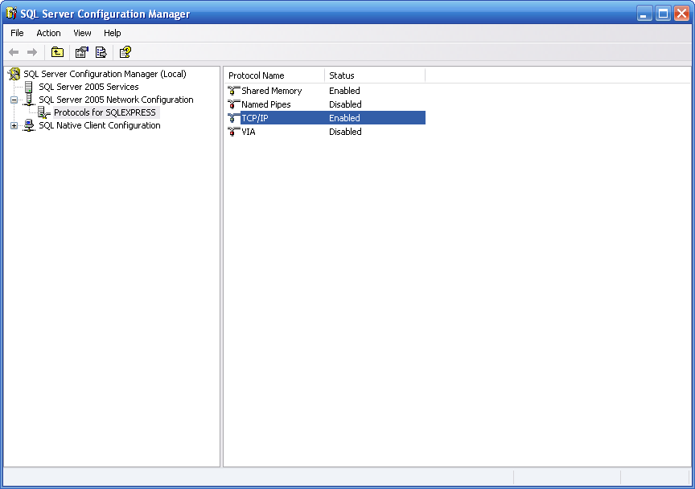
Double click on TCP/IP > IP Address > Enter port 1433 in TCP Port
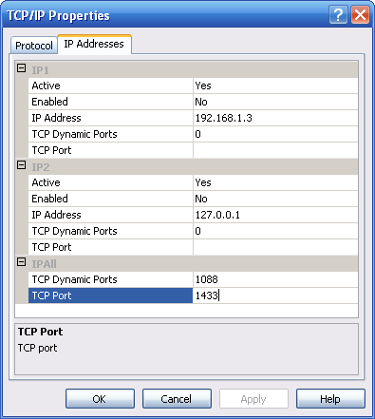
Restart SQL Service
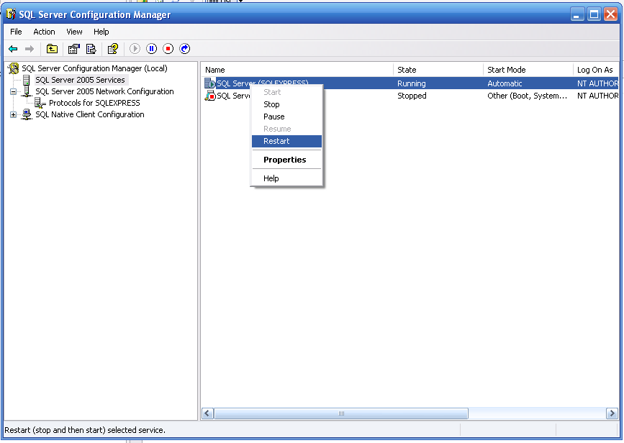

B2. Second : Start →All Programs→ Microsoft SQL Server 2005→ SQL Server Management Studio.
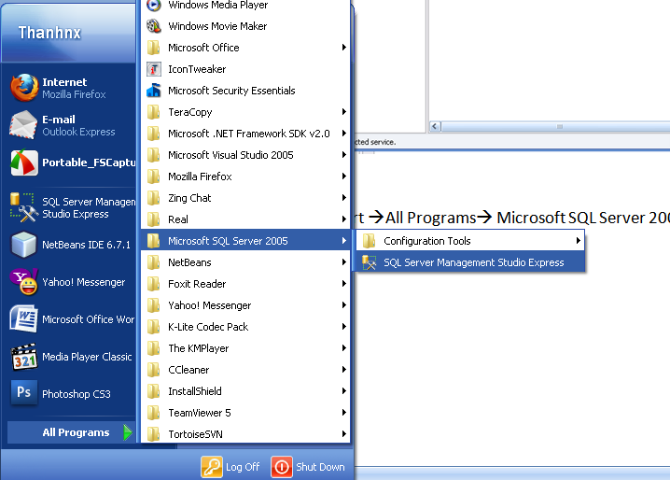

B3. Login SQL Server Authencation
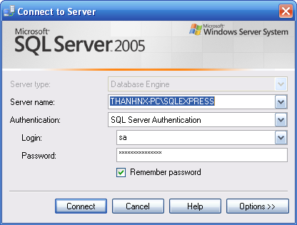

B4. Right-click Security and select New Options -> Login ...
- After selecting the Login displays a dialog
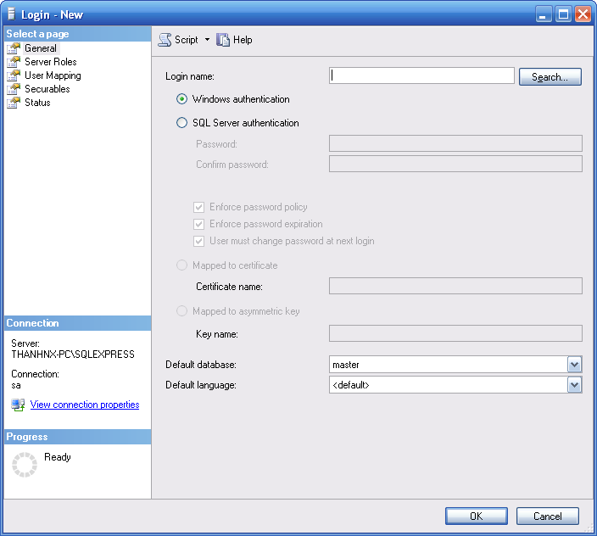
- Login name: sa
- Select SQL Server authentication
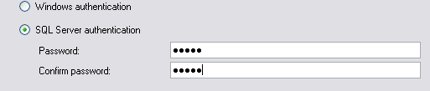
- Enter Password: sa
- Enter Confirm password: 123456

B5. Connection and then click Disconnect Now
- Login with your username and password just created

B6. File > Open file EMTSDB.SQL

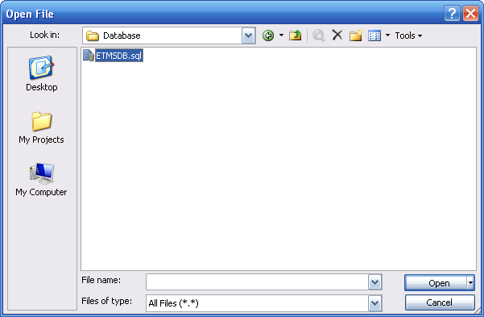
CTRL + A select all > F5 to create database
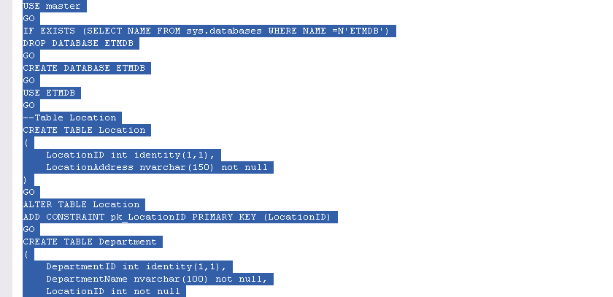

After you perform steps following.
Steps 1: Run Employee Transfer Management.msi
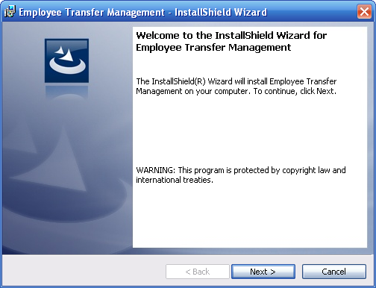
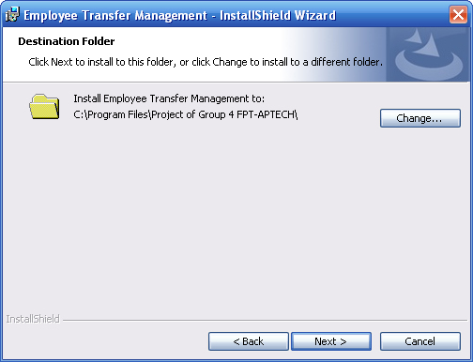
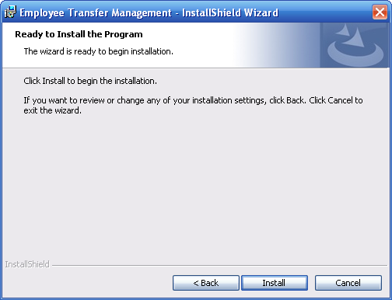
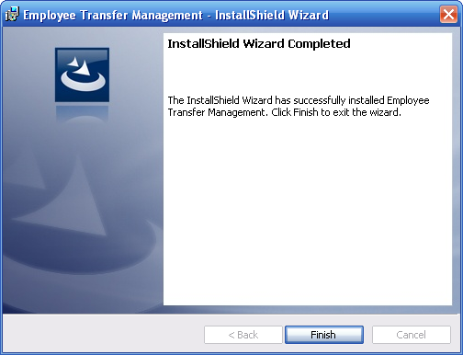
Step 2: Click Run:

Login to ‘EMTS System’ use username and password:
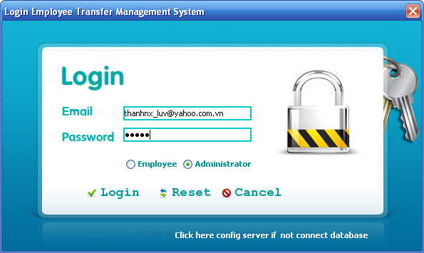
Login Admin:
UserName: thanhnx_luv@yahoo.com.vn
Password: admin

After login system and add new employees to login employee

